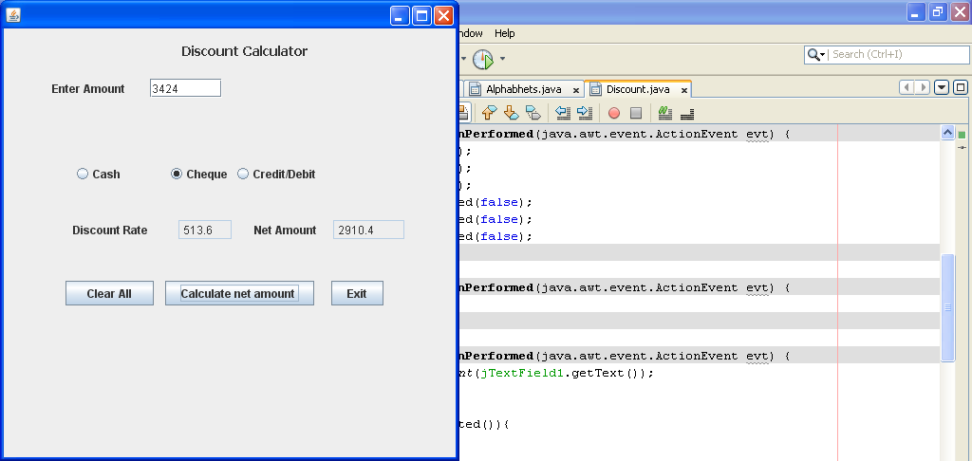

private void jButton1ActionPerformed(java.awt.event.ActionEvent evt) {
jTextField1.setText(" ");
jTextField2.setText(" ");
jTextField3.setText(" ");
jRadioButton1.setSelected(false);
jRadioButton2.setSelected(false);
jRadioButton3.setSelected(false);
}

private void jButton3ActionPerformed(java.awt.event.ActionEvent evt) {
System.exit(0);
}

private void jButton2ActionPerformed(java.awt.event.ActionEvent evt) {
Integer a=Integer.parseInt(jTextField1.getText());
double discamount=0;
double netamount=0;
if(jRadioButton1.isSelected()){
if (a<10000);
discamount =a*0.20;
jTextField2.setText(" "+discamount);
if (a>=10000) ;
discamount =a*0.25;
jTextField2.setText(" "+discamount);
}
if(jRadioButton2.isSelected()){
if (a<15000);
discamount =a*0.10;
jTextField2.setText(" "+discamount);
if (a>=15000) ;
discamount =a*0.15;
jTextField2.setText(" "+discamount);
}
if(jRadioButton1.isSelected()){
if (a<10000);
discamount =a*0.10;
jTextField2.setText(" "+discamount);
if (a>=10000) ;
discamount =a*0.12;
jTextField2.setText(" "+discamount);
}
netamount=a-discamount;
jTextField3.setText(" "+netamount);

}

private void jRadioButton1ActionPerformed(java.awt.event.ActionEvent evt) {
if(jRadioButton1.isSelected());
jRadioButton2.setSelected(false);
jRadioButton3.setSelected(false);
}

private void jRadioButton2ActionPerformed(java.awt.event.ActionEvent evt) {
if(jRadioButton2.isSelected());
jRadioButton1.setSelected(false);
jRadioButton3.setSelected(false);
}

private void jRadioButton3ActionPerformed(java.awt.event.ActionEvent evt) {
if(jRadioButton3.isSelected());
jRadioButton2.setSelected(false);
jRadioButton1.setSelected(false);

